**SPRINT THREE**

Project Manager: Dr. Blanche Cohen

Scrum Master: Nick Miller

Product Owner: Francesco Limoni

Team Members: Omar Bitar, Jacob Watters, and Dustin Shaver

Introduction

Team 3 is creating a simple drawing program we are naming “Pixel Image Editor” (or PIE for short). It is coded in Ruby, using the FXRuby gem libraries. This program is written specifically for a desktop computer or laptop, not a tablet or mobile device. The GitHub repository link is: <https://github.com/FrancescoLimoni/P.I.E>

Research Progress and Project Demonstration

Each team member researched for this project individually depending on their experience. Everyone acquired advantages concept of the syntax in Ruby and FXRuby. The program demonstrated today is the result of our previous sprints goals combine with the goal for the third sprint which are create a having drawable canvas, change the brush color, and a visual representation of the layer panel. We have reached the point in which the software started to gain more functionality that will allow future clients a quick access to the app’s functionality. Also, we wanted to update some UI features (user Interface) in order to make the user’s experience more comfortable and pleasant. Each team member was responsible to maintain its modules working without compromising the integrity of the entire app. The modules are listed on the next page.

* **Canvas Module** – The blank canvas where the user are able to draw.
* **Brush Module** – A side bar with different “brush sizes” for the pixel editing. This ranges from using a brush that is 1 pixel by 1 pixel to some larger size, which is currently not decided upon.
* **Color Module** – A side bar composed by two submodules. On the upper side there is with a variety of buttons arranged in a straight line while on the bottom side there is a matrix element that contains a NUMBER HERE of button that allow the user to change color.
* **Toolbar Module** – The toolbar across the top of the screen where the buttons to Save and access program documentation are.
* **Layering Module** – A side bar where the user will organize the different layers to their pixel project.

All of the modules mentioned above then communicate through a Main file, where they are formatted using frames provided in FXRuby.

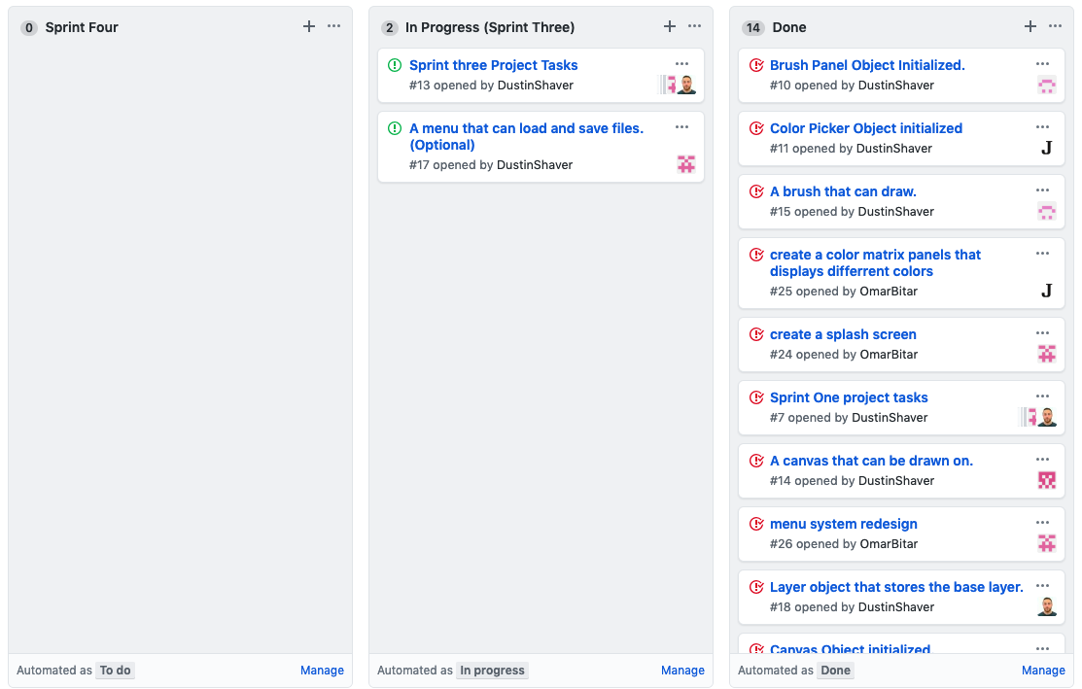Sprint Three Backlog

Comparison to Project Plan

As is expected, our current skeleton is nowhere near as impressive as our program concept (the concept art is shown on the next page). FXRuby has a legacy graphic style. This was not necessarily what we expected when we started programming, but we like it. So far, we are on track to finish the pixel editor by the end of the semester. There are no current plans to scale back the project.

Sprint Retrospective

Last Sprint was number two and we presented a version of software with a full app skeleton, splash screen, and layer panel features. Since than the group worked to improve every single aspect of the app with commitment and dedication. Even though we haven’t met physically the group was able to work remotely and accomplishing the task fixed for this sprint.

Future Sprint

For the future sprint the team agreed to find the time to collaborate more in order to deliver a product capable to communicate with each components brushes to canvas, canvas to layer, brushes to color picker, etc..

Hours

|  |  |
| --- | --- |
| Team Member | Hours Worked for Sprint 3 |
| Omar Bitar | 7 hr 0 min |
| Francesco Limoni | 10 hr 0 min |
| Nick Miller | 10 hr 30 min |
| Dustin Shaver | 12 hr 30 min |
| Jacob Watters | 8 hr 0 min |

Tools and Resources

Language used: Ruby - ruby-lang.org/en/

Gem for GUI used: FXRuby - fxruby.org/

IDE for Ruby: Aptana Studio 3 - aptana.com/

Documentation for FXRuby: Online - rubydoc.info/gems/fxruby/Fox/

Book on FXRuby: FXRuby - https://media.pragprog.com/titles/fxruby/tables.pdf

Guide for Scrums and Sprints: The Scrum Guide - https://www.scrumguides.org/docs/scrum

guide/v2017/2017-Scrum-Guide-US.pdf

Repository Hosting: GitHub – github.com/